Year Group: | 4 | Subject: | History
Term: | Autumn | Topic: | World War II
Why did Britain go to war?
Links to Previous Learning |  | What you should know:
Label a timeline with events of the Anglo Saxon era. |  | Label a timeline with events of World War II
Name and show on a map the names of the Anglo-Saxon kingdoms. |  | Use a map to show the identity of the Allies and Axis powers
Name the reasons why Anglo Saxons came to England. |  | Show where some of the major battles took place.
Use evidence to ask questions and find answers to questions about the past. |  | Explain how and why we went to war.
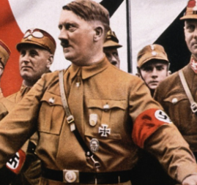
Key Fact: World War II started in 1939 and ended in 1945; it lasted for 6 years!

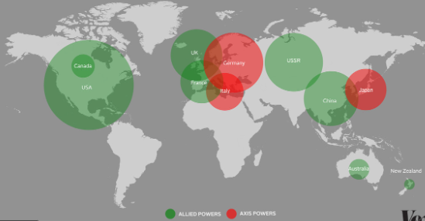

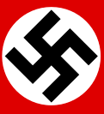
Key Vocabulary
justify | to show or prove to be right
decade | the period lasting ten years
conflict | war or battle (as a result of a serious disagreement)
significant | something that is important
At home: draw or find a good online timeline of Anglo Saxon times. Then, explain the timeline to an adult.
