Year Group: | 1 | Subject: | Geography
Term: | Autumn 6 | Topic: | Maps of the World

What I already know… |  | 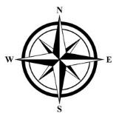  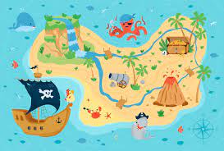 | What I know now…
I have looked at a world map when looking at festivals and compared it with the UK.  I can draw fairy tale maps of traditional stories and use treasure maps in exploring time.  I can use maps of the school to explore |  |  | Discover what a globe, an atlas and a map is.  I can draw a compass with the points North, South, East and West.
New vocabulary |  |  | What I can do at home
North Pole | the top of the globe |  | Look at a map and find the compass marked on it.  Use google maps to plan a trip.
South Pole | the bottom of the globe
equator | the imaginary line around the middle of the earth

