Year Group: | 1 | Subject: | History
Term: | Spring | Topic: | Rosa Parks
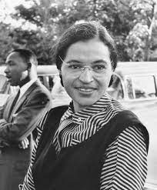
What I already know… |  | 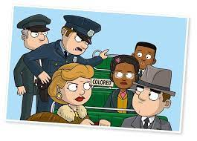 | What I know now…
I know about the lives of people around them and their roles in society  I know that it is ok for people to be different. |  |  | I know what Rosa Parks protested about.  I can list some of the things that happened to Rosa Parks after she got on the bus that day  I know why the Black Lives Matter Movement is important.
New vocabulary |  |  | What I can do at home
law | a set of rules |  | Find out why football players and other sport players “take the knee” at the start of each game. Why do you think they do this?
segregation | keeping people apart because of their race, gender or religion
significant | important

