Year Group: | Reception | Areas of Learning: | Personal, Social and Emotional Development, Physical Development, Communication and Language, Expressive Art and Design, Understanding the World
Term: | Summer | Topic: | Amazing Animals

What I already know… |  | 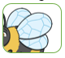  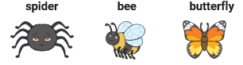  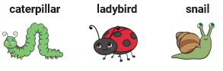  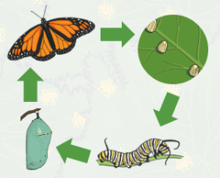  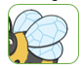  Can you name the minibeast body parts?  Can you name any more minibeasts?  The life cycle of a butterfly. | What I know now…
I can name some jungle animals.
I can name some farm animals.
I can name some minibeasts.
I can name the body parts of some animals.
I can name some different places where I might find animal habitats.
I can talk about some ways that animals are the same and some are different.

New vocabulary |  |  | What I can do at home
Minibeast | A small animal like an insect or a spider. |  | Go on a minibeast hunt in your garden or a local park and see how many different ones you can find.  Use a bug catcher pot or magnifying glass to look up close at minibeast body parts. Make sure you handle them very carefully!
Habitat | Where something lives.
Life cycle | Changes that a living thing goes through as it grows.

