Year Group: | Reception | Areas of Learning: | Personal Social and Emotional Development, Communication and Language, Physical Development, Expressive Arts and Design, Understanding the World.
Term: | Autumn | Topic: | Christmas

What I already know… |  | 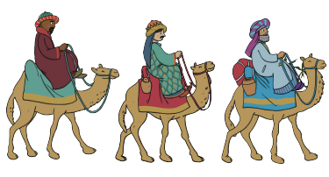  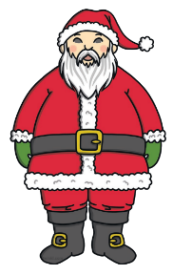  The Three Wise Men are characters from the Nativity story. Can you think some more characters?  Sending letters to Father Christmas and putting up Christmas trees are traditions at Christmas time for some people.  Do you have any Christmas traditions? | What I know now…
I can talk about religious beliefs about Christmas.
I can talk about different ways that Christmas is celebrated.
I can talk about family traditions at Christmas time.
I can compare and contrast characters from stories, including people from the past.

New vocabulary |  |  | What I can do at home
Jesus | An important figure to Christians who the whole Christian faith is based upon. |  | Christmas time is a time to think about ways we can be kind and helpful to others. Find a way that you can help someone in your family.  Talk about signs of Christmas time you see around the local area.  Find out how Christmas is celebrated in different countries around the world.
Nativity | The story of the birth of Jesus from the Bible.
Bethlehem | A small town known as the birthplace of Jesus.

