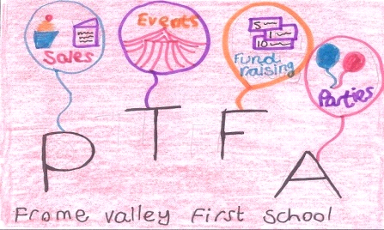
1st Prize – Family passes to eight Dorset Attractions: 1st Prize – Family passes to eight Dorset Attractions:
Abbotsbury Children’s Farm, Pirates of the Pavilion Summer Panto, Abbotsbury Children’s Farm, Pirates of the Pavilion Summer Panto,
Swanage Railway, Farmer Palmers, The Tank Museum, Swanage Railway, Farmer Palmers, The Tank Museum,
Athelhampton House, Lulworth Castle, Dorset County Museum Athelhampton House, Lulworth Castle, Dorset County Museum
Worth over £250 Worth over £250
Frome Valley First School’s PTFA Frome Valley First School’s PTFA
Summer Raffle Summer Raffle
2018 2018
Over £600 worth of prizes to be won Over £600 worth of prizes to be won
£1 per ticket £1 per ticket
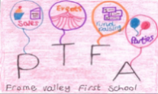
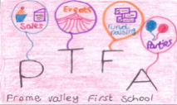
Raising money for a new school sound system! Raising money for a new school sound system!

2nd Prize 3rd Prize 4th Prize 2nd Prize 3rd Prize 4th Prize
Food & Wine Lifestyle Prize Produce Hamper Food & Wine Lifestyle Prize Produce Hamper
Experiences Bundle Experiences Bundle Draw date: 27th June 2018 (after Celebration Assembly) Draw date: 27th June 2018 (after Celebration Assembly)

