Year Group: | 4 | Subject: | Computing
Term: | Autumn 1st Half | Topic: | Computer Systems and Networks

Links to Previous Learning |  | What you should know:
To explain how digital devices function |  | To describe how networks connect to other networks
To name input and output devices |  | To recognise how networked devices make up the internet
To recognise how digital devices can change the way that we work |  | To know websites can be shared via the World Wide Web (WWW)
To explain how a computer network can be used to share  information |  | To describe how content can be added and accessed on the World Wide Web (WWW)
To explore how digital devices can be connected |  | To recognise how the content of the WWW is created by people
To know the parts of a network |  | To be able to discuss the consequences of unreliable content
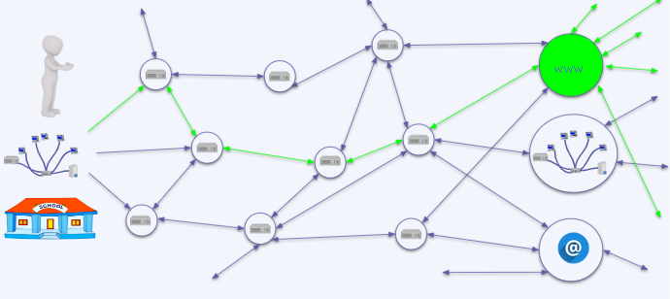
Key Fact: The internet is not the World Wide Web! It is many computer networks from all over the world connected by routers. It does include www and others such as email.

What should I question and think about when I see information online?
At home: describe to an adult…
-what is a computer network; router; the Internet.
Key Vocabulary
router | enables messages to be passed between networks via switches
internet | a global network of networks
digital device | electronic object that can store, give and display information
input | a place where, or a device through which, energy or information enters a system
output | a place where power or information leaves a system.
website | a collection of pages under one name
webpage | a single page or document on the WWW

