Year Group: | 1 | Subject: | Geography
Term: | Autumn | Topic: | Local Study

What I already know… |  | 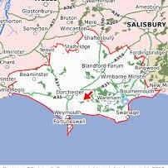  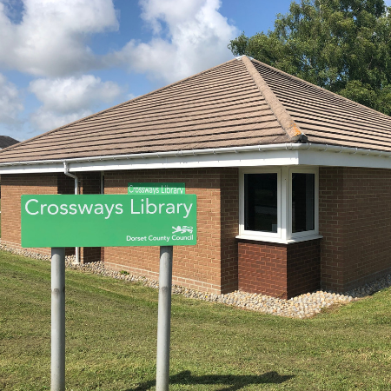 | What I know now…
I have walked around the village looking at local features.  See that our village is different from other places.  Learn to explore the natural world around you. |  |  | I can locate five different features on a map of a village.  I can find a county on a map of England.  I can find a place on a map of Dorset.
New vocabulary |  |  | What I can do at home
place | geographical point, such as town, city etc. |  | Walk around another local place and talk about what facilities are there.  Find out where your grandparents live on a map.
village | a group of houses, together with other buildings such as a church & a school in the countryside
coastal | a place near the sea

