Year Group: | Year 2 | Subject: | Art and Design
Term: | Autumn Term | Topic: | Weather

Links to Previous Learning |  | What you should know:
How artists use different colours to paint the weather. |  | Use thick and thin brushes.
How would a dark rainy picture make you feel? |  | How to mix primary and secondary colours.
What colours would you use in a sunny picture? |  | Use some of the ideas of artists studied to create pieces.
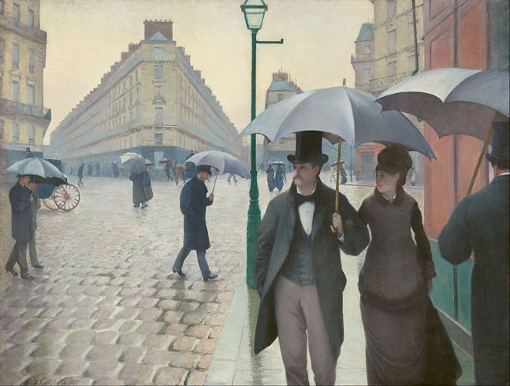
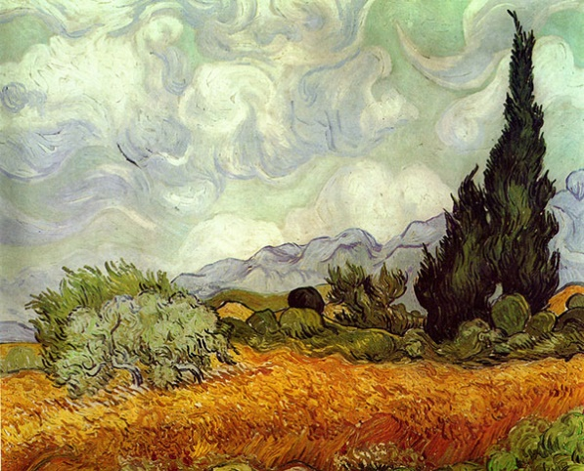
Key Fact: Artists use different colours and tones to express different moods.
How do different colours make you feel?

Key Vocabulary
secondary colours | colours formed by mixing two primary colours
tones | lighter, darker or brighter shades of the same colour
effect | something that produces a particular impression
horizontal | flat and level with the ground or edge

At home: Go for a walk and look for a landscape to sketch.
What colours would you use to paint it?

