Year Group: | 1 | Subject: | Geography
Term: | Autumn week 12 | Topic: | Extreme Weather

What I already know… |  | 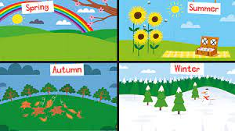  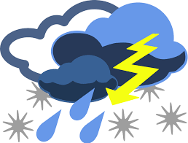 | What I know now…
I know that there are some important processes and changes in the natural world around me, including the seasons. |  |  | I can recognise common weather extreme weather symbols  I know what is a heatwave, a drought, a flood, and a monsoon.
New vocabulary |  |  | What I can do at home
drought | a lack of water due to hot weather |  | https://www.channel4.com/programmes/britains-wildest-weather  These are programmes you can watch together.
flood | a large amount of water covering places that are usually dry
hurricane | very strong winds in a circular pattern  a large column of rotating air

