Year Group: | Year 2 | Subject: | Geography
Term: | Autumn Term | Topic: | Weather and Climate

Links to Previous Learning |  | What you should know:
Define the word climate. |  | How to ask and answer geographical questions.
Define the word weather. |  | The seasonal weather patterns in the UK.
Use a map to find and label places on the equator. |  | The location of hot and cold areas of the world in relation to equator and the North and South Poles.
Key Fact: Different locations have different climates depending on where they are in the world.
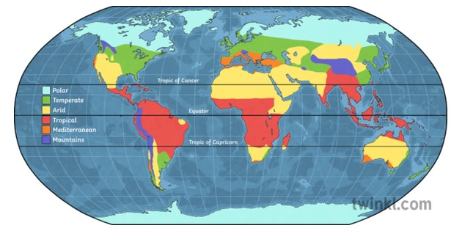
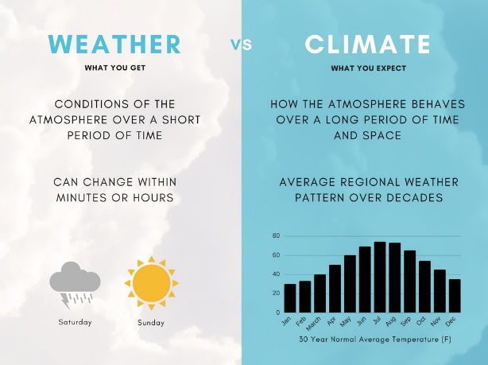

How is the world’s climate changing?

Key Vocabulary
equatorial | near the equator
tropical | in the tropics of Cancer and Capricorn
vast | huge
thrive | to grow or develop very well

At home: Explore the met office website: https://www.metoffice.gov.uk/ and compare weather in different countries around the world.

