Year Group: | 4 | Subject: | Science
Term: | Autumn 1st Half | Topic: | States of Matter

Links to Previous Learning |  | What you should know:
Ice is a solid and melts into water. |  | Compare and group materials together, according to whether they are solids, liquids or gases.
Water is a liquid and can boil into steam. |  | Observe that some materials change state when they are heated or cooled. .
Steam is a gas. |  | Measure the temperature at which some materials change state in degrees Celsius (°C).
Water can freeze back into solid ice. |  | Explain the Water Cycle including evaporation and condensation.
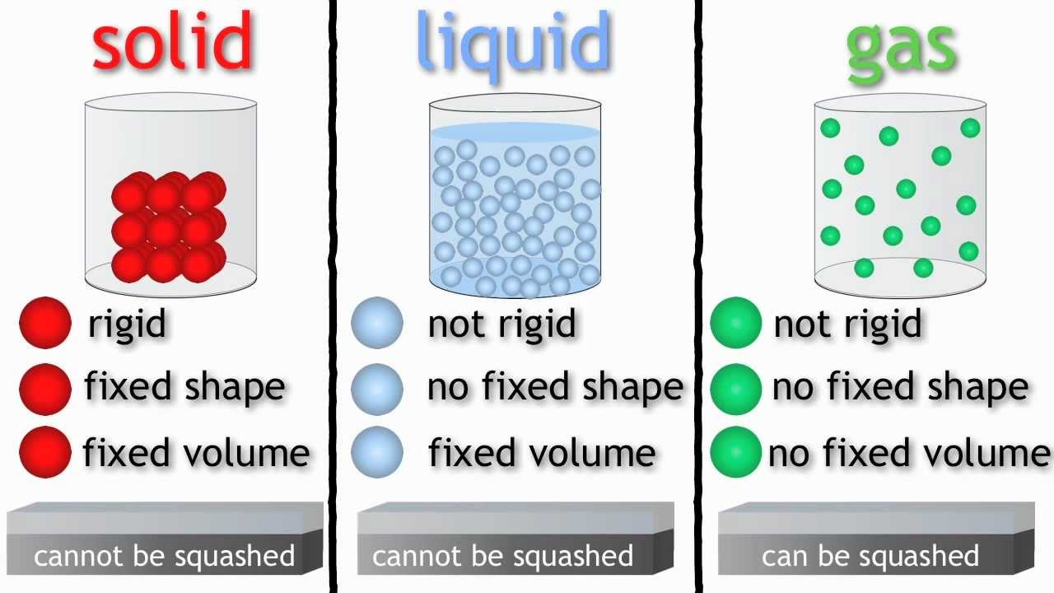
What is the relationship between temperature and states of matter.?
Key Fact: solids, liquids and gases are the 3 states of matter. All substances can change their state: solid > liquid > gas.
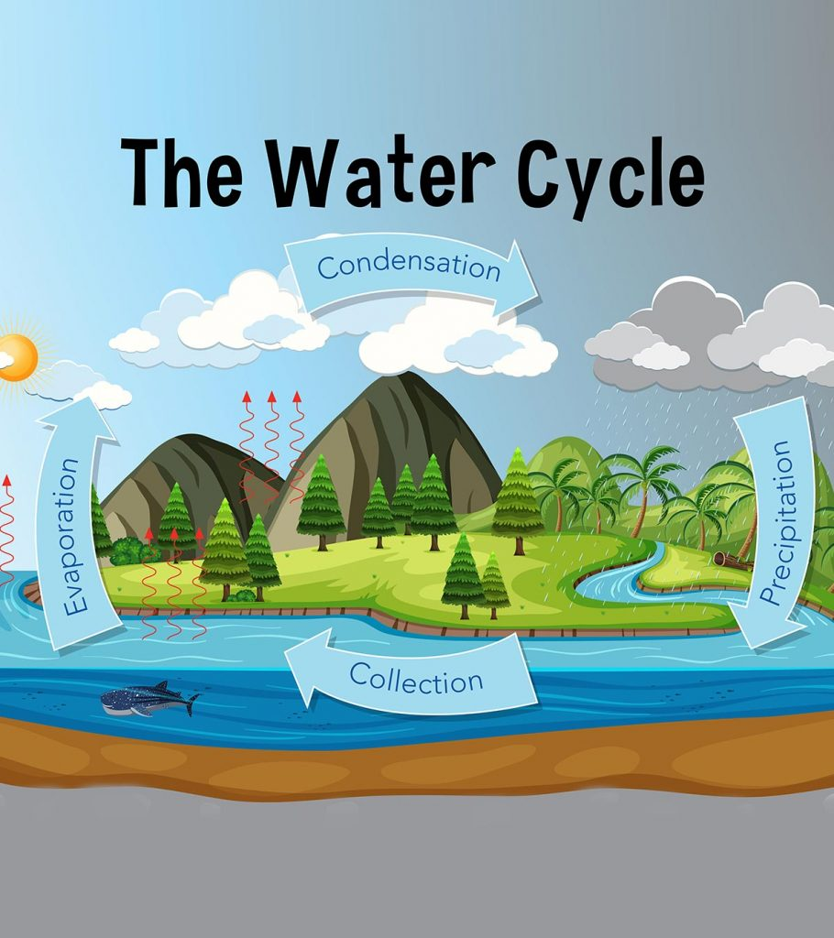

Key Vocabulary
solid | fixed shape; firm and stable; not a liquid or gas
liquid | able to flow freely; like water or oil; no fixed volume
gas | able to flow freely; will fill a space
evaporation | the process of turning from liquid into vapour
condensation | a vapour or gas turning into a liquid

At home:
Draw and explain the water cycle to a grown up.
Investigate-always, sometimes or never: gases are lighter than solids?

