Year Group: | 1 | Subject: | Geography
Term: | Autumn week 8 &10 | Topic: | Climate and Weather

What I already know… |  | 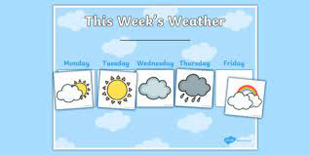  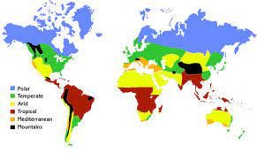 | What I know now…
We have looked at the weather and used weather charts each morning.  We have looked at how the weather changes each season. |  |  | I can locate and label the areas around the Equator.  I know the difference between weather and climate.
New vocabulary |  |  | What I can do at home
temperature | how hot or cold a place is |  | Watch the weather forecast on the television.  Keep a weather diary and explain what the season is by the temperature and type of weather.
climate | the expected weather in a place
weather | the conditions in a place at a particular time

