Year Group: | Year 2 | Subject: | Geography
Term: | Autumn Term | Topic: | Local Study

Links to Previous Learning |  | What you should know:
Find different features on a map understanding the symbols. |  | Make a simple map.
Find places on a map of England. |  | Use basic symbols in a key.
Find places on a map of Dorset. |  | Use grid references e.g. A1, B1.
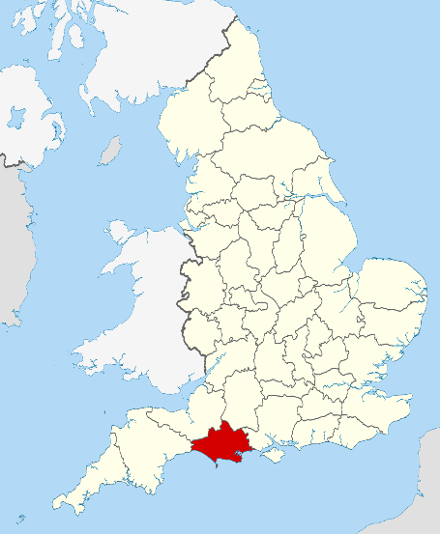
What do the symbols on a map mean?
Key Fact: I know what a village is.
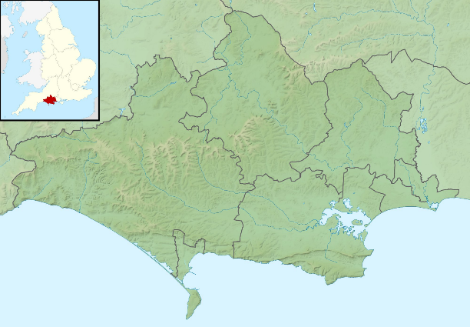

At home: Look at a map together and work out the symbols.
Key Vocabulary
rural | relating to, or characteristic of, the countryside or country life.
locate | to find out where something or someone is.
urban | densely populated area e.g. a city

