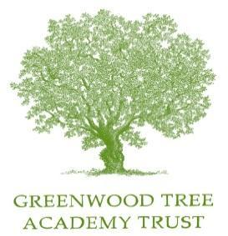

Frome Valley CE First School

Handbook for Parents of
New Children in the Early
Years Foundation Stage
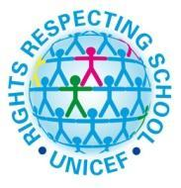
2022-2023

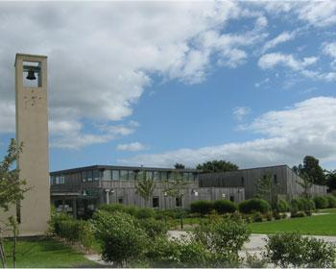

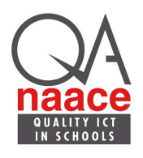

Welcome to Frome Valley CE First School.
We look forward to welcoming your family into our school.

Phone/fax: 01305 852643
Email: office@fromevalley.dorset.sch.uk
Website: www.fromevalley@dorset.sch.uk
General Information

How the Classroom is Organised

The layout of the Reception classroom is planned to support children with settling into school and establishing routine. The classroom is split into eight main areas which are: construction, mathematics, reading, role play, creative, writing, small world and outside. The areas within the classroom help children to explore and discover resources they need to support their learning and play without adult support. This, in turn, supports the children in developing their independence. The different areas are planned to support the development of knowledge and understanding across all areas of learning outlined within the Early Years Foundation Stage as well as supporting growth in confidence and self-esteem in all children. Classroom displays are vital in Reception class. We have classroom displays that assist children’s learning (for example our phonics and mathematics boards) and we have displays used to simply show off the fantastic work that children have created in school! We have our own outdoor area that we share with preschool, which is available for children to use regularly throughout the school day.

How the School Day Starts

Reception children enter the school through the door to the right of the school’s main entrance. This is Reception own door. The door will be opened by a member of staff at 8.40 am. Parents are asked to say their goodbyes at the door, allowing the children to come into school independently and take on the responsibilities of finding their peg, hanging up their coats and putting their belongings in their drawers. Table top activities and handwriting takes place in the classroom until the bell rings at 8.50am to notify the start of the school day. If you and your child arrive late (after the second bell at 8.50am), please go to the main office and sign your child in the Late Arrivals register.
At the start of every school day, a special helper is chosen at random and they have special responsibilities for the day, such as standing at the front of the line and collecting the snack.

How the School Day Ends

As the end of the school day approaches at the start of the school year, children will sit together and listen to a story. We also like to discuss ‘one thing I have learnt today’ and ‘one thing I enjoyed about today’ before children go home. This will help them to think about what news they could share with their parents when they are collected. The school day ends at 3.15pm and Reception children are collected from the main playground. Children will be sent to you by a member of the Reception class team. If a child is being collected by someone other than parents, please ensure that a member of staff is informed beforehand.

The Reception School Day

- Collective Worship: This takes place in school every day. On Tuesdays and Thursdays this is whole school worship in the hall and the Reception children are gradually introduced to this, beginning by joining the rest of the school one day per week. There is class assembly on Mondays and Wednesdays when the children remain in the classroom. Friday is ‘Singing Praise’ which the children are, again, introduced to gradually.

- ‘Exploring Time’: Learning through play is a key aspect of the Early Years Foundation Stage and our planned ‘Exploring Time’ system is an effective way to achieve this within the classroom. During this time, a range of planned structured activities (which the children can choose themselves) are made available alongside focused activities with either the teacher or teaching assistant. ‘Exploring Time’ is a favourite in Reception as it enables children to scaffold their own learning and learn through their personal interests and choices.

- Phonics Teaching: Phonics teaching (the start of reading and spelling) starts straight away. We teach phonics through Read Write Inc (RWI) which is a nationally recognised scheme for teaching reading. Each week, we send home a RWI book which the children practise reading at home with their parents. We send home ‘phonic pouches’- plastic pouches containing phonic flashcards - which can be used to support the understanding of phonics at home. A phonics information evening for parents takes place in the Autumn term and offers more information about phonics teaching and learning.

- Snack Cafe: at 10 o’clock, children are asked to wash their hands and choose a piece of fruit or vegetable that has been supplied free to all young children by the Government. Snack cafe is a time for children to enjoy their snack and sit and talk with friends around tables or on the carpet if they wish. Children are encouraged to try all fruits and vegetables but will never be forced to eat anything they do not want. At 10.15am, the children finish their snack and go out to play.

- Playtime: The children join other children on the school playground or field for playtime. Normally, the class teacher will also join the children for the first few days. Children also have Year 4 buddies that will support them in playtime over the first few weeks.

- Buddies: Year 4 ‘buddies’ is a system used to support Reception children with settling into school life. During the first half of the autumn term, ‘buddy time’ is planned into the school week and is a time for the older children to talk and play with their buddy and help them settle into school.

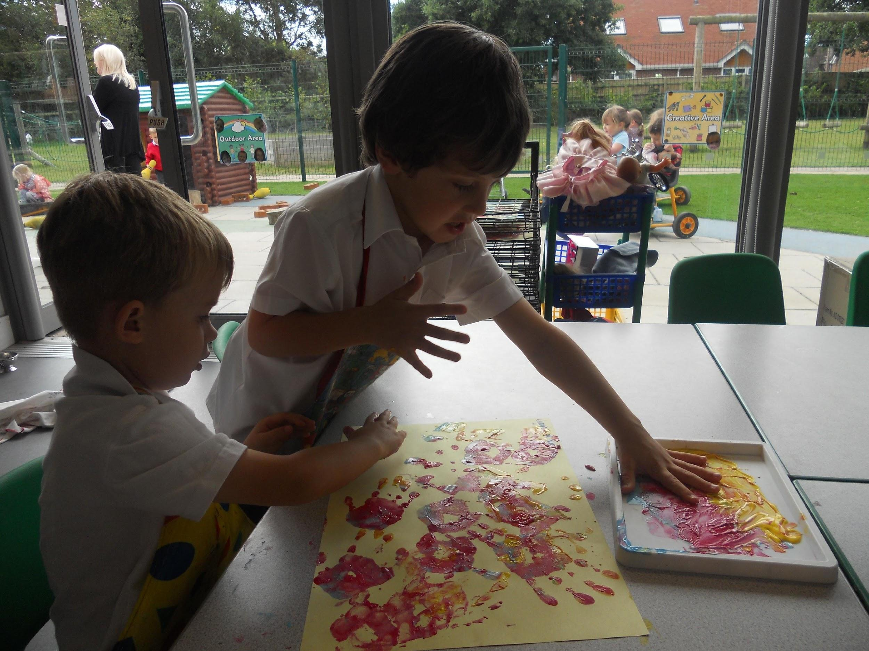
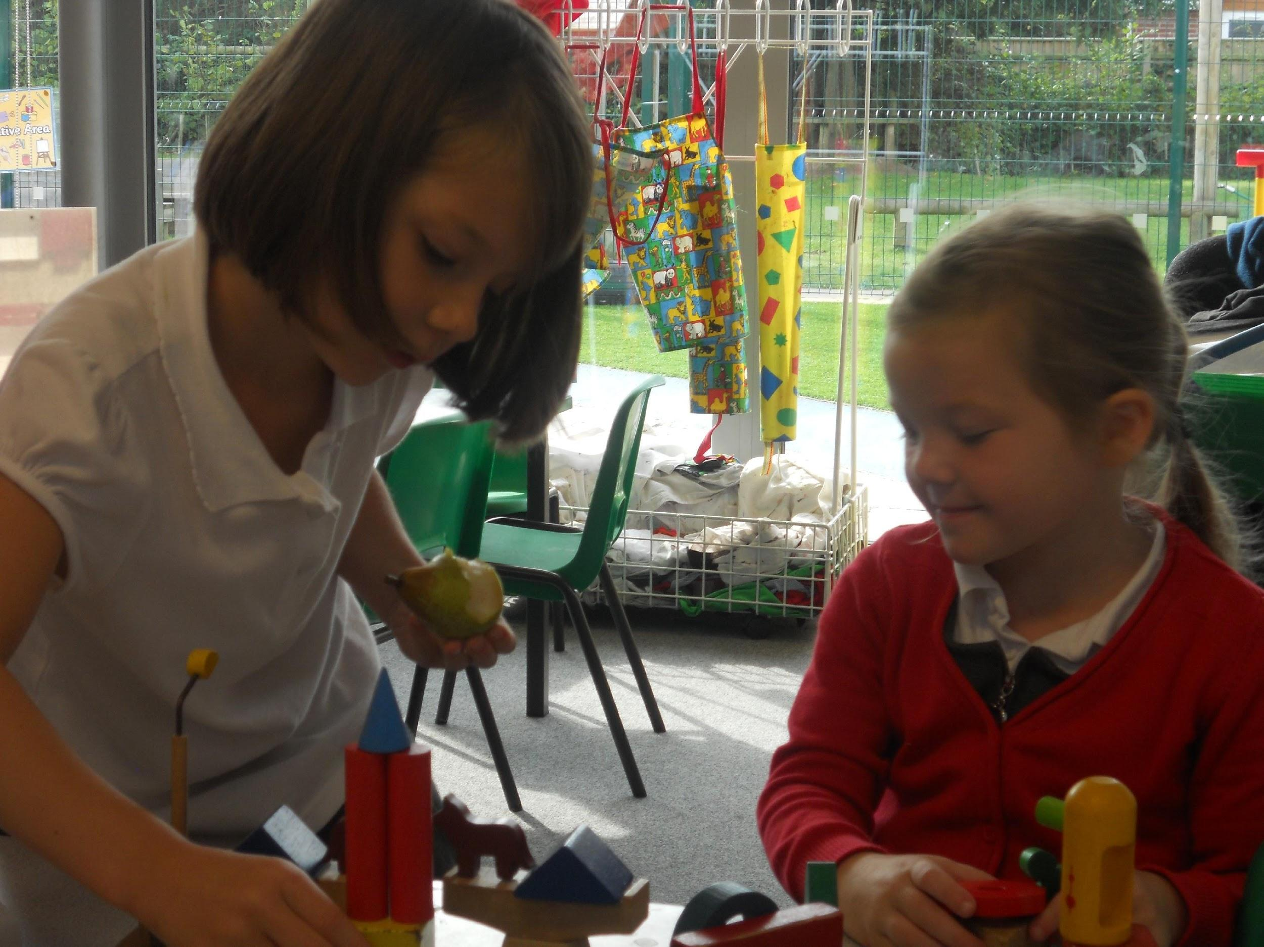

The Curriculum

The Early Years Foundation Stage: The children in the Reception class work on the Early Years Foundation Stage (EYFS) curriculum that began for them at preschool. There is much more information on this in the EYFS handbook which is given to all parents of children in this stage.

The Areas of Learning: All teaching and learning in Reception class in planned in accordance to the 7 areas of learning set out in the EYFS. These areas are split between prime and specific areas of learning, shown below.

The prime areas of learning are:
- communication and language
- physical development
- personal, social and emotional development
The specific areas of learning are:
- literacy
- mathematics
- understanding the world
- expressive arts and design

Teaching is often not solely focussed on one of the areas of learning. Within the lessons, it is common for aspects of two or three areas of learning to be included. Literacy and mathematics are our key subjects and these are integrated across most teaching that takes place.

- Curriculum Statements: At the beginning of each half term, parents will receive a curriculum statement. The curriculum statement outlines which topics will be focussed on and what learning will be taking place during the upcoming weeks.

Positive Behaviour

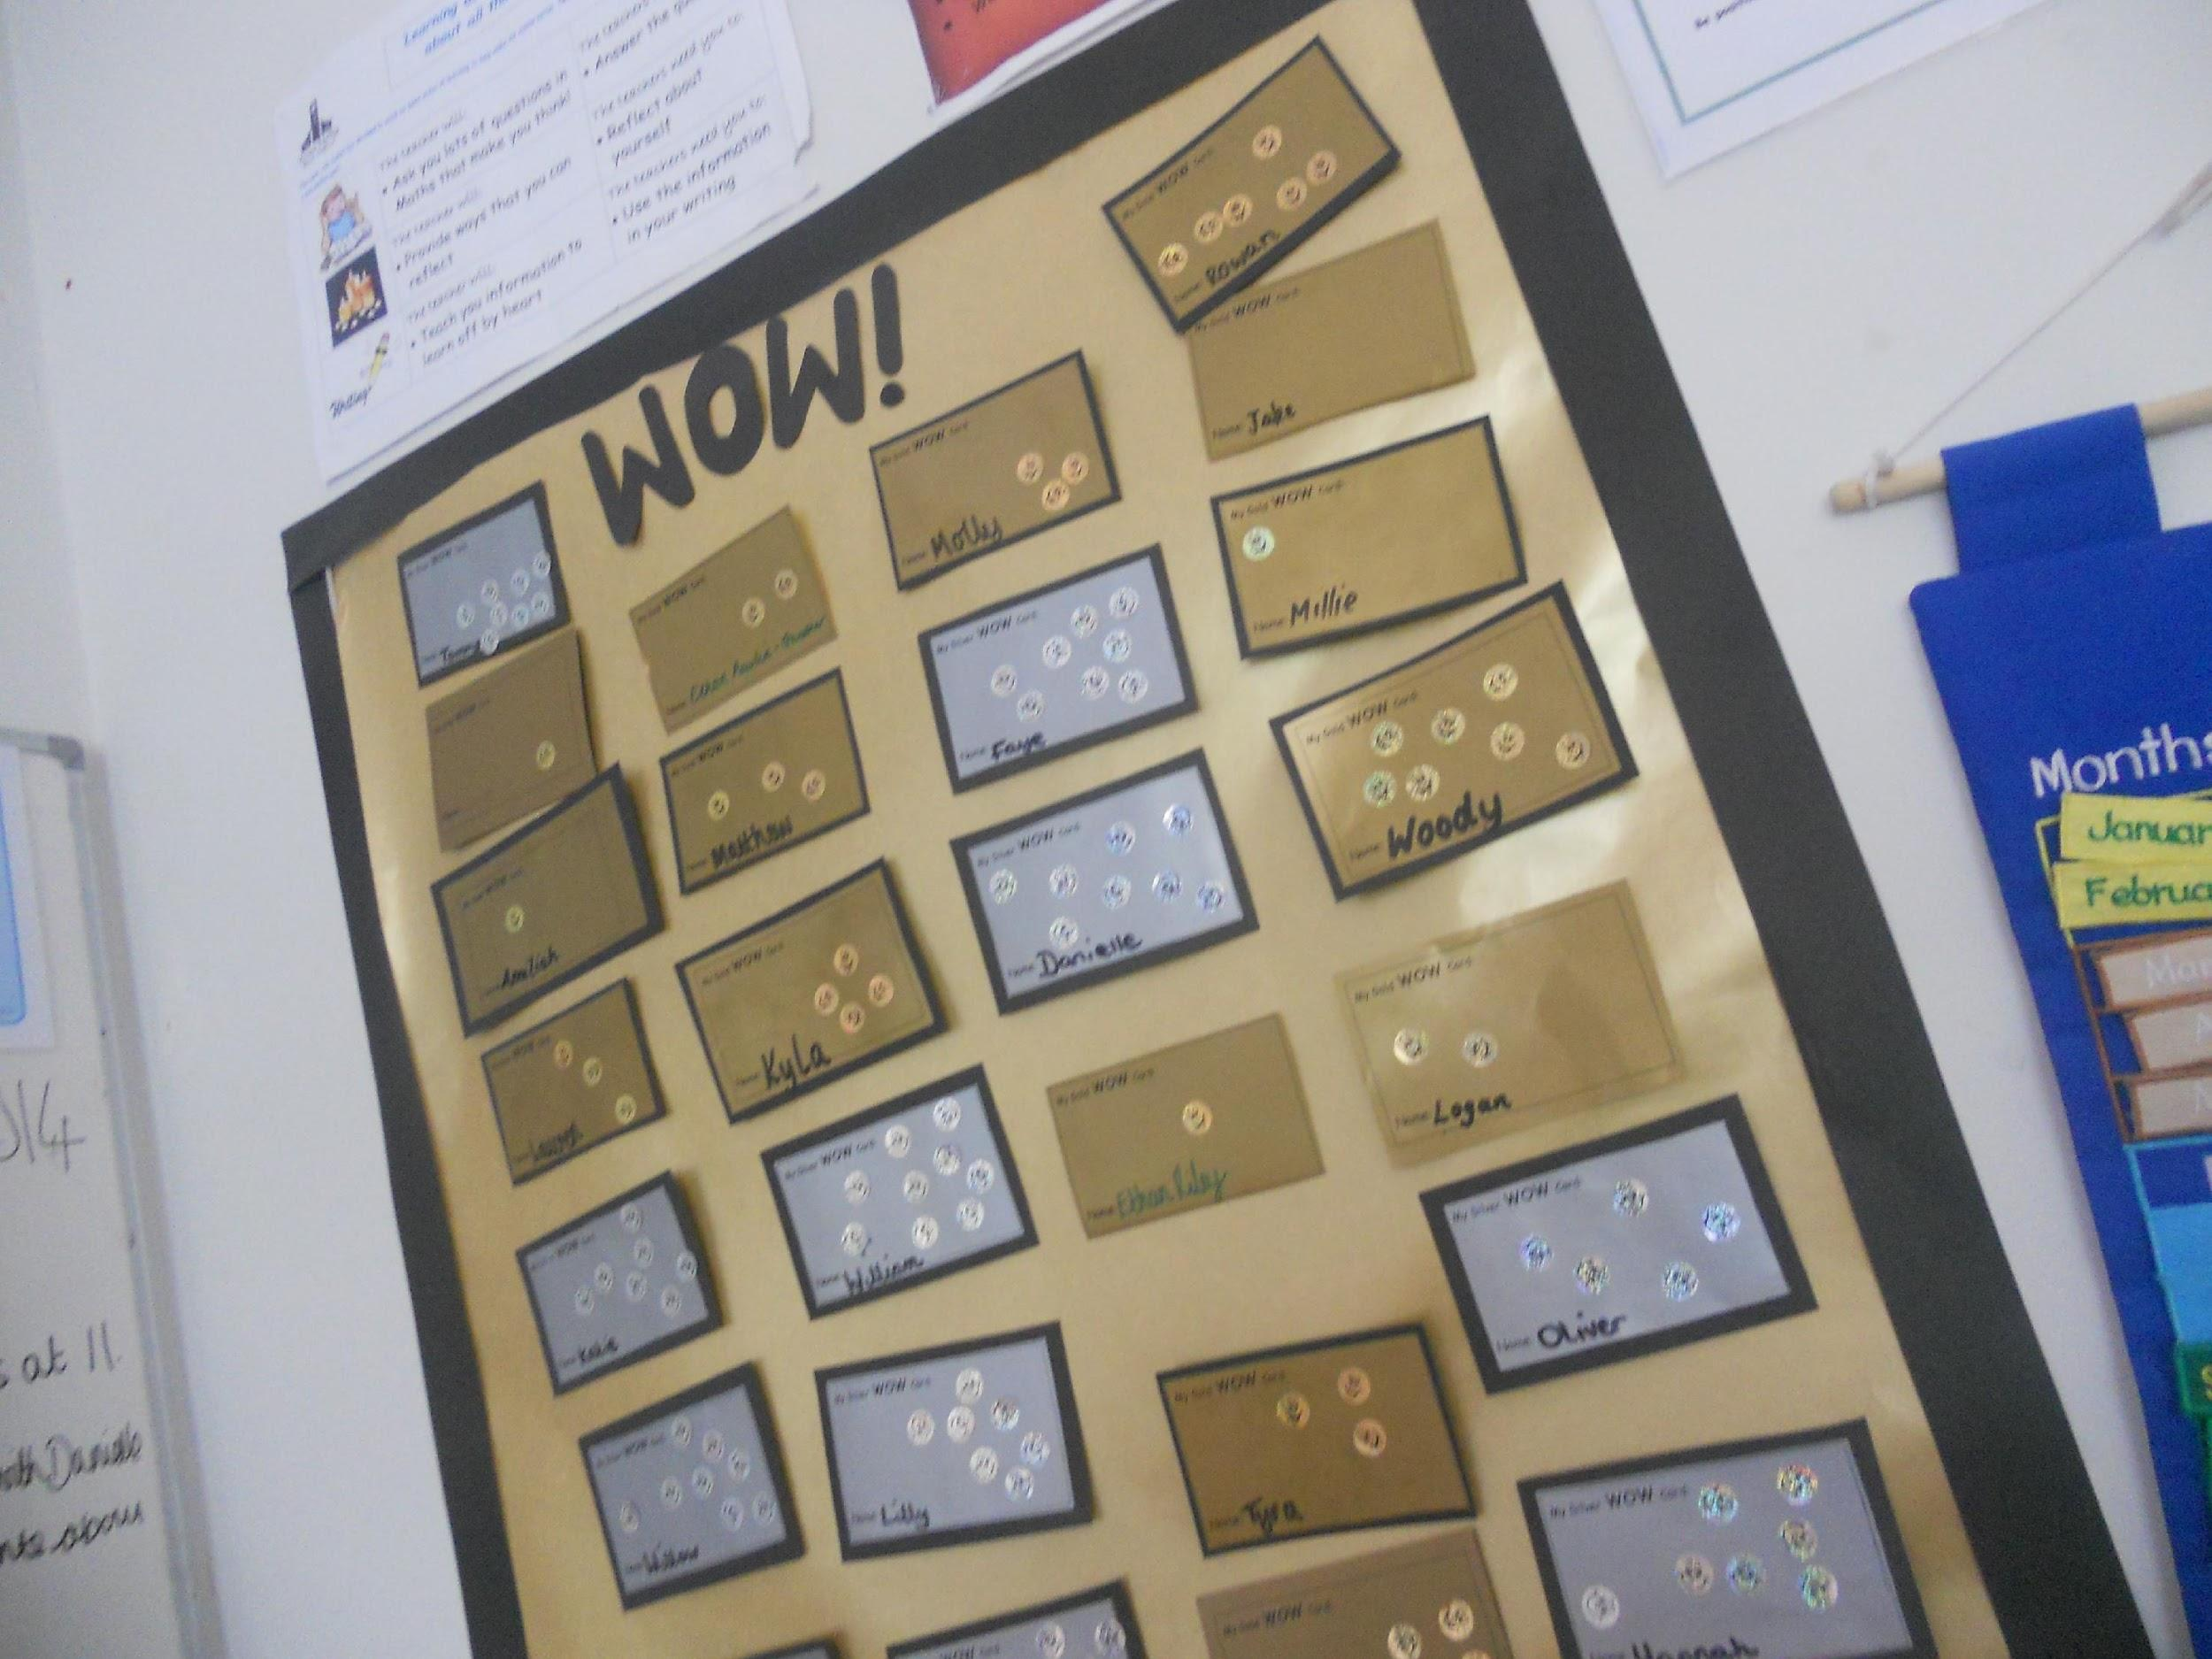
- WOWs: WOWs are given to children completing a particularly good piece of work or if they have made a good contribution in class discussions. All children begin at the ‘bronze’ level and when 10 WOWs have been collected they move on to silver. A further 10 WOWs are collected before moving to gold and completion of this gains the child a book. They choose this book from the Headteacher’s office and it is then presented at the annual ‘Celebration Assembly’. Children completing bronze and silver WOWs are also celebrated at the termly ‘Sharing Assembly’ when we all share their success.

- Class Dojos: Children earn Dojo points for good behaviour and for making good choices in school. Children earn Dojo points for such areas as being a good citizen, being ready to learn, being on task etc… Dojo points are also linked to our 3 school core values of respect, perseverance and compassion. Children collect Dojo points throughout the year and can ‘cash in’ their points for prizes when they have collected 50, 100, 250 or 500 points.

- Star of the Week: A star of the week is chosen every Friday. The winner of the star of the week will be a child who has tried hard all week and has made good choices. The winner receives a star of the week certificate and their name is displayed on the star of the week display board in the classroom. They are allowed to choose an activity for all the class to play with during all exploring time in the following week.

- Golden Rules: Golden rules are the rules we all live by in school and the children in the Reception class are introduced to them from their first days in school. The children soon know the rules and are taught that their behaviour is their responsibility and they can choose to keep the Golden Rules or they can choose to break them. If they choose to not follow the rules then there will be consequences.
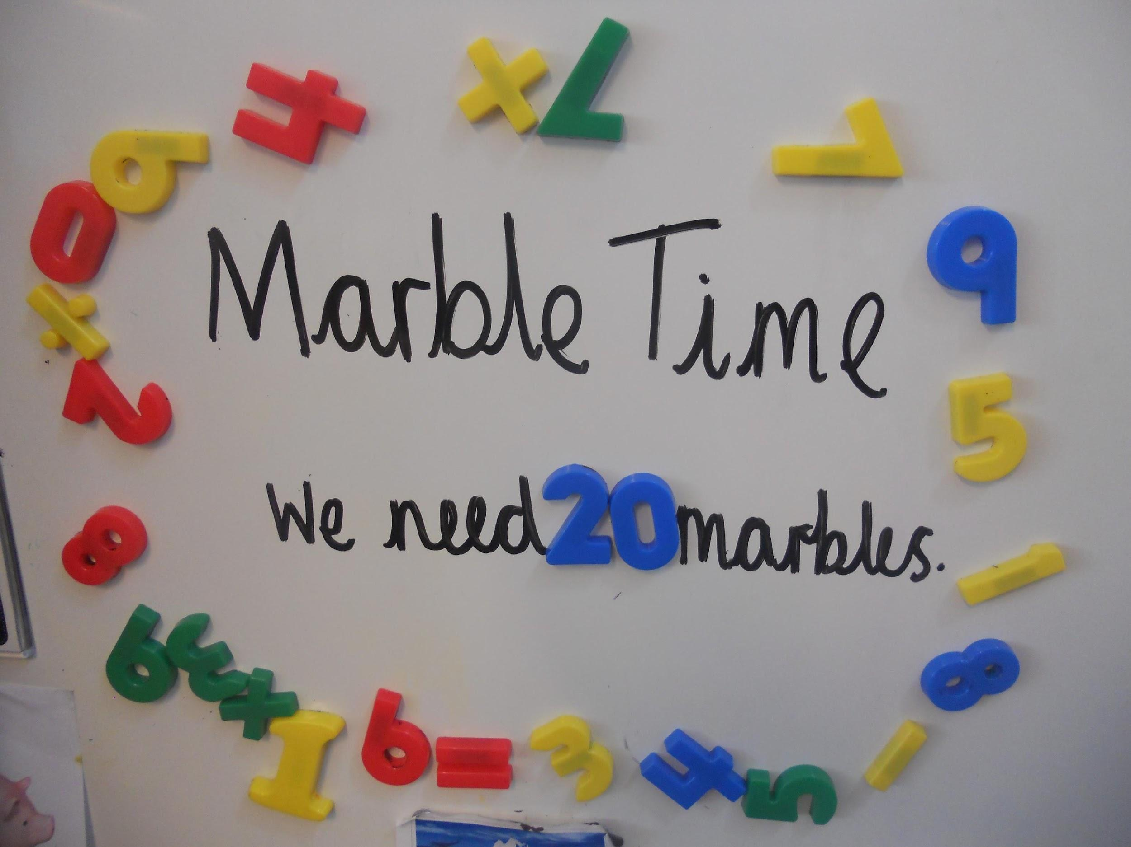
Marble Time: Marble time is earned by the children through meeting a class target. The target could be to not call out or to listen to others when they are talking. Each time it is recognised that the children have remembered this target, they are rewarded a marble. When the children have collected 20 marbles, they receive marble time. During this time, the children are allowed to bring in one toy from home to play with for the last 45 minutes of the school day. Parents will be informed if there is going to be marble time via a letter at the end of the day.

School Events in the Autumn Term

Harvest Festival takes place early in the autumn term. The School Council decide which charity the school will support each year. The Harvest Festival service is held in school during the afternoon and the Reception children will make a contribution to this which may be showing a picture they have painted or reciting a nursery rhyme.

Sharing Assembly is held each term in school during an afternoon towards the end of the term. Each class presents an aspect of the work they have been learning during the term for the parents to enjoy. Children completing their bronze, silver and gold WOWs are celebrated. Citizenship certificates are presented to children in each class who have been chosen as being good citizens by their classmates.

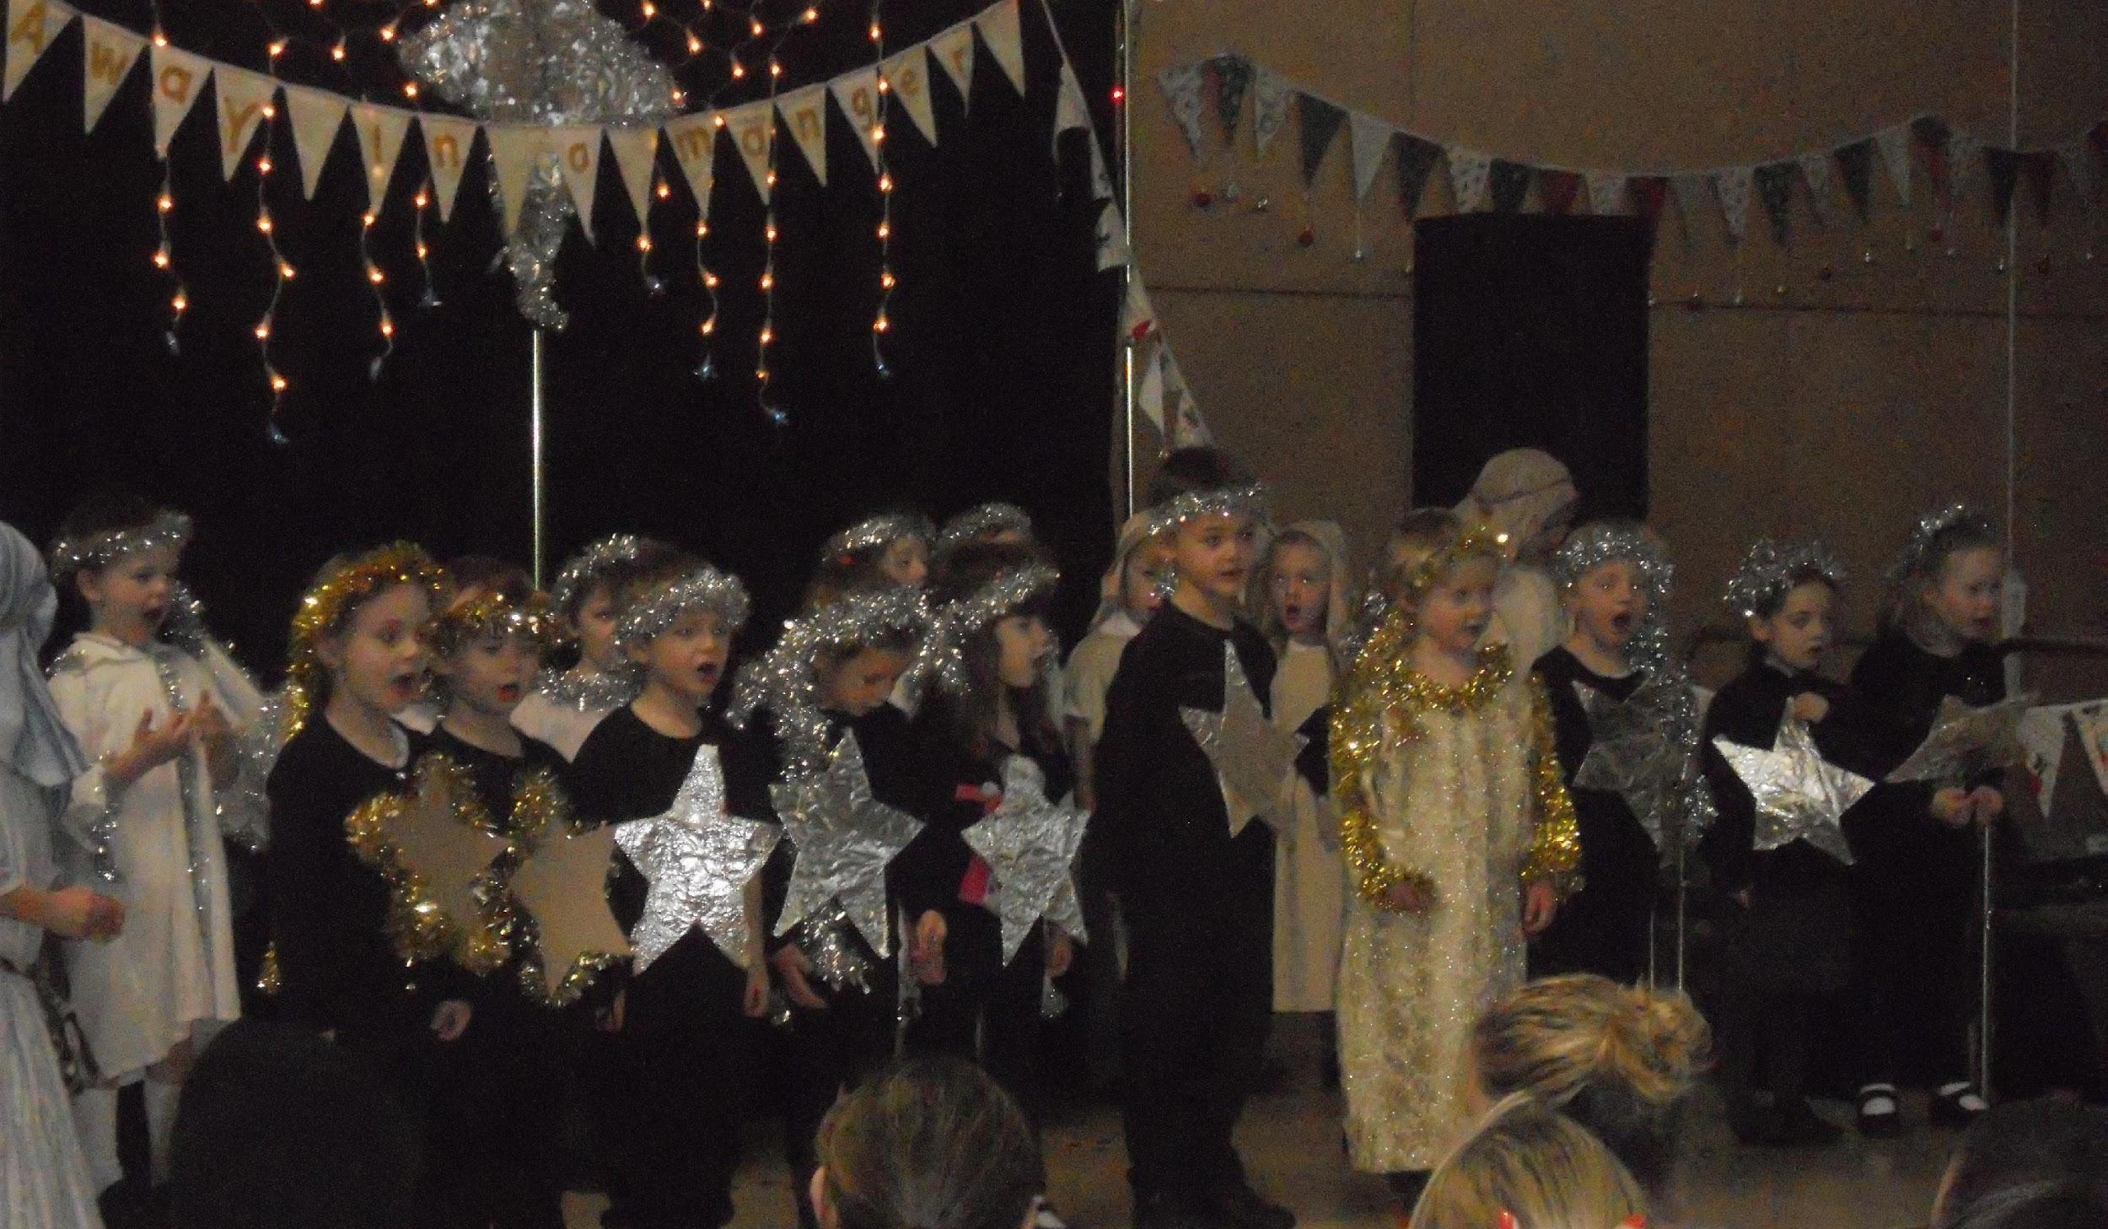
The Nativity Service takes place during the last week of the autumn term. Reception class and preschool join together for the nativity service. The Reception children are some of the Nativity characters and perform a range of different songs. Two children from year 4 help us by narrating the story. The Nativity Service is held on two afternoons and parents are invited to attend one of these.

Carols by Candlelight is an evening event held at the school for Carol Singing and sharing some festive refreshments. Parents and children are all invited to join in with the School Choir leading the singing.

Christmas celebrations start on 1st December. We have a school post box for children and staff to post cards to others in the school. The children love to send cards to the rest of their class and others in the school and parents will often ask the office for a class list of children. We do not distribute class lists of children’s full names, but can issue first names only on request.

The school Christmas Party takes place on the last day of term. The children have party games in the morning and we all have party lunch together in the hall.
The afternoon is taken up with a ‘Special Visitor’ who brings presents for the children, supplied by the Parent Teacher and Friends Association (PTFA).

Parent Interviews are held usually in November. This is for the parents to have a time with the teacher to discuss how their child has settled into school and the progress they are making.

Other School Events

The Spring term:

The School nurse visits the Reception parents to discuss her screening visit. She leaves forms for parents to complete prior to her undertaking the screenings with the children. Parents can attend their child’s screening if they wish.

Spring Showcase is an event similar to ‘Carols by Candlelight’ except that it usually features ‘Songs from the Shows’. The School Choir sing several songs they have learnt. There is a competition for the parents and everyone enjoys this informal event. We do not always hold a Spring Showcase each year.

The school photographer visits to take individual photos of the children and any family pictures that parent’s request.

Sharing Assembly takes place towards the end of the term, as in the autumn term.

The Summer Term:

The school holds its annual May Day celebrations just before the May half term. This is an afternoon event and all the children take part in some dances. Parents are invited to join in too!

The school photographer visits again, this time to take photos of each class which parents are invited to buy.

Sports Day is held during a morning, to avoid the heat of the sun. Parents join in with the Mums and Dads races and we even have a race for the pre-school children.

The Reception annual outing usually takes place in the summer term. Each class has an outing to support a curriculum area.

Celebration Assembly takes place and includes presentations of cups and trophies at the end of the academic year and each class chooses their DASP Citizen for the year.

Parent Interviews take place again this term after the child’s Annual Report has been sent home. Parents are asked to choose a time to meet with the class teacher.

Transfer Day takes place towards the end of the term. This is the day when the Year 4 children visit their Middle school, the new Reception children visit this school and all classes move up one year for the day!

Finally, the Annual School Production has three performances at Crossways Village Hall. Every child in the school takes part with the Reception children having a short appearance on stage. This shows them how participation increases as you go through the school with Year 4 children taking the main parts, including several solo singing pieces and many dances.

Communication with Parents

Mornings and After School: We are always happy to talk to parents about their child. There are ten minutes at the beginning of each day when you can talk to the teacher or after school. If it is of a more serious nature then an appointment can be requested. We always aim to see parents as soon as possible if there is a problem.

News Weekly: Each week, parents receive News Weekly (either a paper copy or by email). This details recent or future events as well as any notices etc...

The School Website: The school website is updated regularly. The website contains important information for parents including policies and further curriculum information. The website also contains information on school events and examples of children’s work. Finally, there is an up to date calendar on the school website.

Emails and Texts: Parents can opt into the school email service. We will then email all letters, News Weekly and other communication to you. Please ensure your email address is kept up to date. We also have a texting service and will text parents with occasional reminders and other important messages such as when the school is closed due to bad weather.

Parents in Partnership

In Reception class, we value parent input into their children’s education greatly. Therefore we use various ways for parents to be as involved with their children’s education as possible.

- Stay and Play: During the school year, parents are sometimes invited into school for a ‘Stay and Play’ session. This session lasts for roughly an hour and are often creative and messy sessions that link to the learning that children have been doing.

- Termly Progress Reports: Each term, parents will be sent home a termly progress report. This is a chance us to share with you how well your children is progressing across the areas of learning. The progress report also allows us to inform you of the next steps for your children’s learning, enabling you to help your child work towards these next steps at home.

- Parent Interviews: Parent interviews take place twice a year, once in the autumn term and once in the spring term. This is a chance for parents to discuss their child’s progress and ask any questions that they may have. Parents are asked to sign up for a time slot prior to the parent interviews. The parent interviews will run between 1.15pm-7pm on one day and 3.15pm-5pm on the following day.

- Drop-In Sessions: We hold half termly drop-in sessions (unless there is a parent interview that half term) when parents can drop into school to speak to the class teacher on their child’s progress and next step. During drop in sessions, parents can look at their children’s books and learning journeys and discuss their child’s work with them. This is a great time for parents to complete a ‘WOW slip’ which allows parents to share with us something they are proud of and something that they didn’t know their child could do!

- Tapestry: Tapestry is an online learning journal that is used to share with you your child’s learning at school. It is also a valuable tool for parents to contribute to their child’s learning. Please use Tapestry by uploading photographs, videos or observations of your child’s learning experiences at home.

- Wow-berries: We are aware that children do a lot of learning at home, and we love to hear from parents when they see their child doing something that makes them feel proud. To support this, we send home ‘wowberries’ (a berry shaped WOW slip). We ask that parents write and WOW moments on the ‘wowberry’ and bring it into school. We celebrate each ‘wowberry’ that is brought into school and it is then displayed on our ‘wowberry tree’ in the classroom and is eventually added to your child’s learning journey.

- The Early Years Foundation Stage Profile: The EYFS profile is an official document that is completed towards the end of the school year in Reception class.

Keeping Children Safe and Healthy

It is of upmost importance for children to feel secure in school.

- Personal Belongings: Children need to become responsible for their own belongings and to know where they are. We ask parents to support the staff in developing this. Children should be encouraged to hang up their own coat and bag, put their own lunchbox on the trolley (this will also help them to recognise it at lunchtime) and take their reading packet into the classroom and put it in their drawers. We also ask that children do not bring in their own toys into school unless it is marble time.

- Sickness and diarrhoea: Sickness and diarrhoea can spread very rapidly in school. Children suffering with either or both of these must stay at home for at least 48 hours from the last time they are ill to make sure they are completely clear.

- Toilets: Toileting is a further area of independence for the children. We hope that all children are able to go to the toilet independently and wash their hands. It does help the children if they can manage their clothes independently and it is helpful if these are easy to pull up and down. Buttons can take time to undo and a delay may result in wet or soiled pants. We fully understand that children have accidents and staff at school will deal with these sensitively. It is helpful if children have a spare set of (named) clothes in school for emergencies as we do change children and send home the soiled items for washing. Parents will be informed verbally or via the home-school diary.

- Nits: Nits (the eggs) and head lice (live creatures) are a problem for any setting with children. We work very hard in school on giving parents and carers information and advice on the prevention and treatment of this. Prevention is clearly better than treatment and long hair should be tied back securely. Parents should check their child’s hair frequently and take action immediately if any eggs can be seen. Treatment can be to use commercial products or to use the ‘Conditioner and Comb’ method.

- Spare Clothes: As well as spare clothes in case of an accident, we also hope that children will have spare clothes in school that are suitable for the weather and other activities that may be taking place. For hot weather, children should have a sun hat in school. In cold and wet weather, ensuring your child has warm, outside clothes and wellies is very important. A bag of spare clothes can be kept on your child’s peg along with their PE kit.

- Water bottles: All classrooms have mains water and the children refill their bottles when they need to, initially with adult support and then independently as the school year progresses. Each child has a named ‘water bottle dot’ in the classroom to make sure they always know where their water bottle is when they need it.

- Milk: School milk may be ordered for children. It is supplied free of charge for children up to the age of 5 years and after that parents will be invoiced. Application forms are available from the office.

