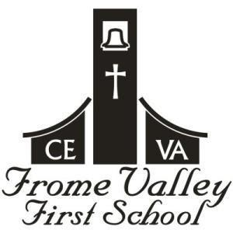
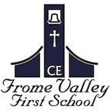
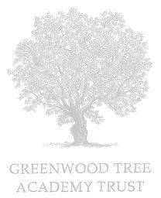

Our School Vision
and Values

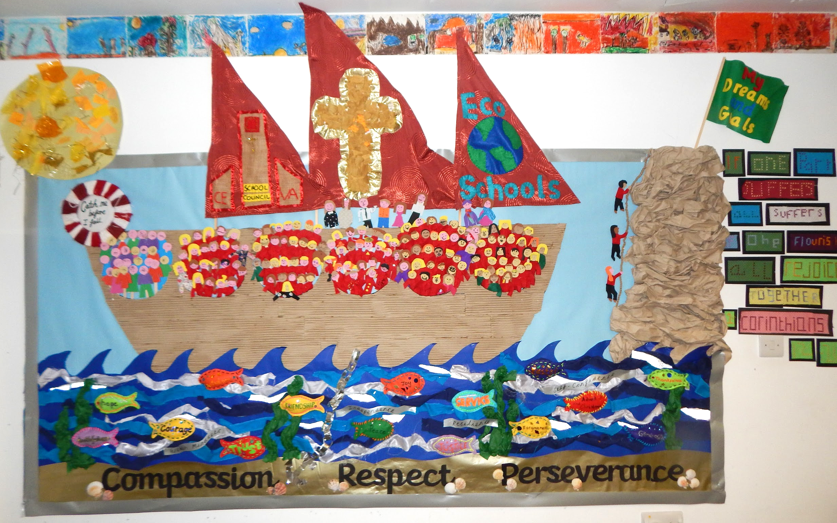

Our School Motto

“Together, with God’s love, we learn,
nurture and grow, without limits.”

We chose these words as they encompass what is important to us as a school.

Together: our strength is working together. This includes staff all working together to achieve the best for our pupils and community. Together, we forge a partnership with the church community and our many stakeholders. Together, in partnership with parents, we support the children in our care with their learning and their wellbeing.

with God love: this is the core of our ethos as church school. We use our vision and values to remind us of our closeness to God and God’s teachings. It reminds us on our journey (our boat) that God is by our side and we can learn from his teachings.

we learn: we focus on all of our pupils’ learning. Our support for SEN pupils is so very important to us and our SENDCO leads us in this area. We want all our children to learn and enjoy learning, alongside learning resilience, perseverance and a growth mindset that you can’t do it yet. We see ourselves as learners too and continually strive, as a school, to learn from research and best practice as well as self-reflection on our own strengths and areas for development.

nurture: at the heart of our school is our Trauma Informed Schools work. We know that the basis for all learning is having a child that is happy. On our boat, there is a lifebuoy with the words: “Catch me if I fall.” We hold deeply the importance of wellbeing and positive mental health. We know the importance of nurturing relationships with an emotionally available adult in school for a child that needs support. We strive to work with our parents and foster supportive relationships.

and grow: we want our children to grow in confidence and resilience. We want them to grow their dreams and goals and to aim high. We want our staff to grow and develop in their role in school.

without limits: this is probably the most important part of our school motto. It is the self-reflection of when we may set limits for ourselves or for others. It’s working together to reach beyond our limits, knowing we are stronger together than alone. Without limits means growing without limits, nurturing without limits, learning without limits and working together with God’s endless love.

Our School Values

Compassion Respect Perseverance

Compassion
We strive to show compassion in how we relate to others. A huge part of our Trauma Informed Schools work is to have empathy for other people. We foster, in our pupils, compassion for others in the world, particularly in times of need.

Respect
Our Eco Schools work is a strong part of our school and we are very passionate about being a Green Flag School. We teach our children not only to respect each other but to respect our environment and God’s world.

Perseverance
We teach our pupils of the need to persevere, particularly in our school work. This links to teaching children the importance of resilience. Our Growth Mindsets work also reminds us of perseverance.

Our School Bible Quote

“If one part suffers, all suffer together;
if one flourishes, all rejoice together.”
1 Corinthians 12.26

We chose this quote because of its strong link to our Trauma Informed Schools work and our dedication to supporting the wellbeing of those in our care. Our working as a team is paramount to the success of the school. We support each other and know that it is the sense of ‘togetherness’ in all that we do (learning, nurturing and growing) that helps us to continue to improve.

Our Vision Board

Number | Object | What it means to us and why it is in the picture
1 | The sun | The sun is God and Jesus shining down on us. They shine down on us all the time.
2 | The boat | We chose a boat as we live near to the sea. The boat is the school. We are there, altogether, on the boat. Sometimes the sea is rough, sometimes, it is calm.
3 | The sails | The sails guide us on our journey. We chose School Council and Eco Schools to be on the sails as they are such an important part of our school and help guide us to make important decisions. The cross on the main sail reminds us, through Collective Worship and RE, to use the teachings of God to make the right decisions in our lives.
4 | Portholes | The portholes represent our whole school community. The first porthole is Preschool, the next is Reception and we continue up to Year 4. After Year 4, there is a porthole for our parents.
5 | Adults on the boat | At the front of the boat is Miss Thorp and the Governors. There is a wheel next to them to help them steer the boat and all of us in the right direction
6 | Adults on the boat | In the middle of the boat, we see members of our church community. They are there to support us and guide us on being part of our wider church community.
7 | The mountain | The mountain reminds us to persevere and to help each other to persevere. You can see children helping each other to climb the mountain, particularly when things get tricky. At the top of the mountain, you will see a flag that says “my dreams and goals”.
8 | Lifebuoy | The life buoy has the words “Catch me if I fall”. This links to all our work on Trauma Informed Schools and for our children to know that we are there when they are hurt, worried, scared or needing any other emotional support.
9 | The sand | The sand is the bedrock of our school and it’s here where you will find our 3 core values of Compassion, Respect and Perseverance.
10 | The anchor | The anchor keeps the boat safe when the storm is strong. We are anchored to our 3 core values that protect us in stormy times.
11 | The fish | The fish are the Christian values that we learn about through Collective Worship. As the fish travel with the boat so these Christian values travel alongside us in our daily lives.
12 | The waves | The life skills on the waves (such as resilience) help us in our lives as the waves help the boat move forward in the sea.

