Frome Valley
School

Frome Valley

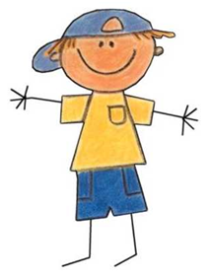
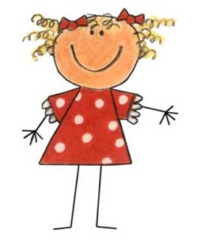
Play, learn and grow together.

School Drive
Crossways
Dorchester
Dorset
DT2 8WR

Tel: 01305 852643 (school office)
Preschool

WELCOME TO FROME VALLEY PRESCHOOL

Thank you for choosing Frome Valley Preschool for your child’s preschool experience. We look forward to getting to know you and your child over the coming weeks and months.

OUR AIM

1. To provide a happy and positive learning experience where children’s educational, social, physical, spiritual and emotional needs will be met, thereby preparing them for their journey through school.

2. To provide a welcoming, supportive and inclusive environment where parents are valued as partners and can participate in and benefit from being involved in the life of the preschool.

3. To provide equal opportunities for all children and their families.

4. To encourage each individual child in our care to develop at their own pace.

GENERAL INFORMATION

Ofsted registration Number: EY448858

School email: office@fromevalley.dorset.sch.uk

Preschool email: g.florance@fromevalley.dorset.sch.uk

Telephone number: 01305 852643 (School Office)

School opening times; 8am - 6pm Monday – Friday, term time only

Preschool opening/session times: 9am – 12pm & 12pm - 3pm Monday – Friday term time, only

STAFF
Gemma
Manager of the preschool.
Designated safeguarding lead.
Behaviour Coordinator
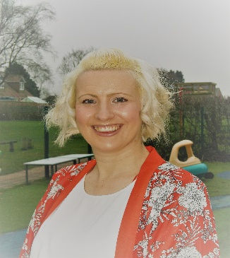

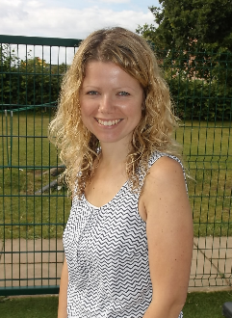
Emma
Deputy manager of preschool
Deputy designated safeguarding lead.

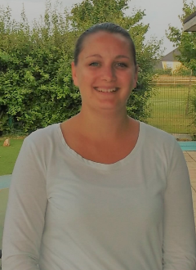

Kylie
Childcare assistant
SenCo Lead

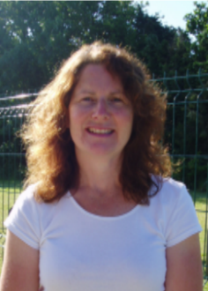

Paula.
Childcare assistant

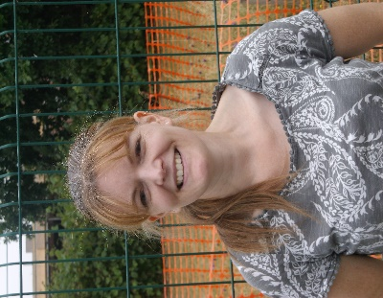
Connie
Childcare assistant

We comply with the staff ratios to children as specified by the Office for Standards in Education (OFSTED) which are one adult for every four 2 year olds (1:4) and eight 3 and 4 year olds (1:8)

BEFORE STARTING PRESCHOOL

Starting preschool can be both exciting and daunting for you and your child but we want your child to be happy and feel secure at Pre School and we want you to feel the same about leaving them with us. All children are different and there are no set rules when leaving them for the first time. You know your child better than anyone else and we want you both to feel comfortable with any arrangements made when settling them into the group.
It is unusual for a child not to settle once a parent has gone; most children settle very quickly. The excitement of new surroundings, gentle reassurances by our staff and playing with other children usually helps to settle them. Your child will be allocated a key person who will help your child settle. If we have any concerns about your child we will always ring and discuss these concerns with you. Between us we can overcome any difficulties
There are a number of ways in which parents and other key adults can support your child’s transition to preschool during the days leading up to them starting.
- Spend time talking to your child about all the exciting things they will be doing at preschool such as painting, playing in the home corner, riding bikes, making new friends, the list is long. Preschool is about exploring new activities but it is also about the children developing the interests they share home. So be sure to include these in your conversations.

- Always be honest with your child and tell them you will not be staying with them at preschool but you will be picking them up after their play.

- Make buying a bag or a lunchbox to bring to preschool an exciting occasion.

- If your child is not used to being left with other people, you could arrange for them to play at a grandparent or close friend’s house for a short while to get them used to being away from you

- Read books about starting preschool like “Maisy goes to Preschool” by Lucy Cousins. Or “My First Day at Nursery School” by Becky Edwards. You could visit the Library together where you will find more stories.

- Help your child to be independent. Encourage them to take off or put on their own clothes, especially hats, coats, cardigans, socks and shoes and to go to the toilet ( if they are at this stage)

KEY PERSON

In order to keep communication and feedback of information to parents regarding their child at a high standard, we have a key person system. The key person has a special responsibility for a small group of children within their care as well as their usual role across all areas in the preschool. Your child’s key person will be able to discuss with you your child’s progress and daily activities.

BEHAVIOUR
We promote positive and constructive behaviour and support children in developing self discipline and self esteem in an atmosphere of mutual respect and encouragement using The Incredible Years
Programme. All children are cared for with equal care and concern irrespective of gender, race, ethnic origin or disability. For further more in depth description please read our Behaviour Policy given to you in our policy documents.

FOOD AND DRINKS

Mid morning the children are provided with a drink of milk or water and a choice of healthy snack. Children are not required to bring in their own snack or drink unless there are any special dietary needs or requirements.

The birthdays of children and staff are celebrated at preschool on or near the day of their special day. On these occasions we do permit cake or special biscuits to be bought in to share at preschool. We ask to be informed in advance if this is to take place to enable alternative provisions to be made for children with dietary restrictions.

STARTING PRESCHOOL

Arriving and departing

If driving to the school, please park in the school visitor car park (the bottom car park). At 9.00am a member of preschool staff will open the main school front door. At the end of the session, when picking up their children, parents should use the preschool door which can be found by going through the gate to the right of the main entrance and following the path round to the left.

If a person other than the persons stated on the authorisation section on the registration form is collecting your child you must inform the preschool. If the person is not known to the preschool they must have some form of identification to show staff and both the preschool and person must be given a password. Parents/carers that are persistently late in collecting their child at the end of their session will be charged a late collection fee.

What to wear at preschool

Please make sure that your child is dressed in clothing and wearing shoes that are suitable for the various activities at pre-school. ‘Crocs’ and open toed sandels are not suitable foot wear. There are always activities where your child is free to explore and experiment with all kinds of materials including messy ones. Therefore, it is best to send children dressed in clothes that are easily washable and not too new. Clothing which they can handle themselves will enable them to practice self-help skills and increase their independence. The children will go outside in all weathers to play and explore and their clothes should be appropriate and reflect the season: wellington boots and waterproof coats are essential for play in the rain. In the summer, please provide a sun hat and apply sun-cream to your child before pre-school.

What to bring to preschool

CLOTHES
We ask that all children bring a complete change of clothes each day in a soft, named bag. -please avoid backpacks as these make your child’s coat peg bulky and restrict their ability to reach their own coat.
It isn’t unusual for children to have an ‘accident’ at preschool especially when a child first starts or if they become so engrossed in play they leave it too late to get to the toilet. The change of clothes may also be needed as a result of over exuberance whilst playing with the water or the paint. All clothing should be clearly named as children do not always recognise their own things
If your child has pierced ears, please ensure that they only wear stud style earrings to preschool. The wearing of chains and necklaces are not permitted.
NAPPIES
If your child is not yet toilet trained, please ensure they have baby wipes and a good supply of nappies. The preschool will dispose of all wet and soiled nappies they change. When you commence toilet training please talk to your child’s Key person so that the preschool can adopt the same routine. We also support the use of reusable nappies, please supply adequate numbers of nappies and linings and also please provide suitable bags for the storage of soiled or wet nappies.

LUNCH
If your child is staying for lunch, you are required to send in a packed lunch (in a labelled airtight container). We are unable to keep them refrigerated so we recommend that they contain a small ice pack. Our School has adopted a healthy eating policy and does not permit sweets and chocolates to be consumed during session times so we would ask that these are not included in lunch boxes.
CAN WE ALSO MAKE YOU AWARE WE ARE A NUT AND MANGO FREE SCHOOL.

PERSONAL ITEMS
A favourite toy or blanket can act as a comforter at preschool especially when a child first starts at preschool but as a general rule we do not encourage the children to bring in toys and other items from home as these often get lost or broken. Frome Valley Preschool cannot accept responsibility for any loss or damage that may occur to clothes or any personal belongings.

ABSENCE AND SICKNESS
Please contact the preschool if your child is going to be absent. Unexplained, irregular or non-attendance will be recorded and monitored for Funding, Safeguarding and Health & Safety reasons. If your child has an infectious illness please keep them away from the preschool. If you are unsure or any queries regarding this fact please discuss this with a member of staff. A guide to infectious illnesses can be found in our sickness policy. If a child becomes unwell while at preschool, we will contact a parent/carer to come and take them home. Fees are still required if your child does not attend due to illness or holiday.

EARLY YEARS FOUNDATION STAGE

The Early Years Foundation Stage (EYFS) is how the Government and Early Years Professionals describe the time in your child’s life between birth and age 5.

This is a very important stage as it helps your child get ready for school as well as preparing them for their future learning and successes. From when your child is born until the age of 5, their early years experience should be happy, active, exciting, fun and secure; and support their development, care and learning needs. All Nurseries, Preschools, Reception classes and childminders registered must deliver the EYFS and follow a legal document called the Early Years Foundation Stage Framework. The EYFS Framework explains how and what your child will be learning to support their healthy development.

Your child will be learning skills, acquiring new knowledge and demonstrating their understanding through 7 areas of learning and development. Children should mostly develop the 3 prime areas first.
These are:-
· Communication and Language
· Physical Development
· Personal, Social and Emotional Development.

These prime areas are those most essential for your child’s healthy development and future learning. As children grow, the prime areas will help them to develop skills in 4 specific areas.
These are:-
· Literacy
· Mathematics
· Understanding the world
· Expressive arts and design

These 7 areas are used to plan your child’s learning and activities and it's designed to be really flexible so that staff can follow your child's unique needs and interests.
Children in the EYFS learn by playing and exploring, being active and through creative and critical thinking which takes place both indoors and outside. All the fun activities that you do with your child at home are important in supporting their learning and development and have a really long lasting effect on your child’s learning as they progress through school.

Even when your child is very young and is not yet able to talk, talking to them helps them to learn and understand new words and ideas.

It is important that you and the professionals caring for your child work together. You need to feel comfortable about exchanging information and discussing things that will benefit your child. Your child will have been assigned a key person whose role is to:

- be your main point of contact within the preschool.

- help your child to become settled, happy and safe.

- be responsible for your child’s development and learning.

- take a careful note of your child’s progress, sharing this with you and giving you ideas as to how to help your child at home.

- create a record of your child’s Learning Journey on the online system called Tapestry, that chronicles their progress through the EYFS framework. You will be given your personal login details for this when your child has started preschool.

EARLY EDUCATION AND CHILDCARE FUNDING

2 year old.
We now accept children from the age of 2 years old. These spaces are limited because they work on a smaller ratio of 1:4. We offer 4 two year old spaces a day in the setting. We are also able to take “Golden Tickets” which entitle some children to 15 hours funded from the government. Please speak to a member of staff if you are unsure if you qualify.

3 and 4 year olds
All children aged 3 and 4 years are entitled to receive 15 hours of free early education funding per week for 38 weeks of each financial year. This starts the term following their third birthday up to and including the term in which they turn five or start at a state maintained school, whichever comes first.

Children born between : | Become eligible for funding from:
1st April – 31st August | 1st September following their 3rd birthday or the  beginning of the school Autumn term
1st September – 31st December | 1st January following their 3rd birthday or the beginning of the school Spring term
1st January – 31st March | 1st April following their 3rd birthday or the beginning of the school Summer term

Regulations permit a minimum of 0.5 hours and a maximum of 10 hours to be taken in any one day. (6 hour session is the maximum available at Frome Valley) The preschool applies for this on your behalf and the funding will be paid directly to us.

30 Hours

You can usually get 30 hours free childcare if you (and your partner, if you have one) are:
- in work - or getting parental leave, sick leave or annual leave
- each earning at least the National Minimum Wage or Living Wage for 16 hours a week - this is £125.28 if you’re over 25
This earnings limit does not apply if you’re self-employed and started your business less than 12 months ago.
You can get 30 hours free childcare at the same time as claiming Universal Credit, tax credits, childcare vouchers or Tax-Free Childcare.
You’re not eligible if:
- your child does not usually live with you
- either you or your partner has a taxable income over £100,000
- you’re from outside the EEA and your UK residence card says you cannot access public funds
To apply you’ll need your details (and your partner’s, if you have one), including your:
- National Insurance number or
- Unique Taxpayer Reference (UTR), if you’re self-employed
It takes 20 minutes to apply. You may find out if you’re eligible straight away, but it can take up to 7 days.
Once you have your unique code you will need to bring it to the pre-school for the second eligibility check. You can then book sessions for your child. (subject to availability) You will also need to confirm eligibility every three months in order to continue claiming the extra funding. This can be done through your personal account with the HMRC. Any questions please speak to Gemma the manager.
FEES

Parents and Carers claiming Early Education and Childcare funding will have their child’s fees paid directly to the preschool by Dorset County Council. Parents not entitled to this funding or who register their child for additional weekly sessions will receive an invoice each month. Fees must be paid during the first week of the month for that month. Fees can be paid weekly if agreed by the manager.
One month’s notice in writing will be required prior to a child being withdrawn from the preschool. If a child’s place is fee paying (not fully funded by Early Education Funding) and a month’s notice is not given, a month’s fee will still be charged.

Fees are as follows:
Session | 2 year olds
Morning (9am-12pm) 3 hours | £15.00
Afternoon (12pm – 3pm) 3 hours | £15.00
All day (9am – 3pm) 6 hours | £27.50

Session | 3 – 4 year olds
Morning (9am-12pm) 3 hours | £11.75
Afternoon (12pm – 3pm) 3 hours | £11.75
All day (9am – 3pm) 6 hours | £21.00

PAYMENTS

Fees can be paid by cash, cheque, childcare vouchers or through internet banking.

Cheques should be made payable to FROME VALLEY FIRST SCHOOL

Internet payments can be set up using the following details;

Account Name; FROME VALLEY FIRST SCHOOL
Bank Name; LLYODS BANK
Account Number: 29284768
Sort Code: 30-92-69

Please ensure that we can identify your payments by using your child’s name as a reference..

WORKING WITH THE WIDER SCHOOL

We are an integral part of Frome Valley School with whom we work in close partnership to provide a stimulating and fun learning environment for all children. The sharing of resources, skills and information about the children in our care enables us to provide a smooth transition for them from preschool into the Reception class. Regular meetings are held between the Reception class teacher and the preschool staff to plan the use of the outside environment, joint activities and to monitor learning and achievement

Please note: Attendance at the preschool does not guarantee a place in the Reception class of the school. All parents will need to apply for school through the normal school admissions procedures.

May 2019

