Year Group: | 1 | Subject: | History
Term: | Spring | Topic: | Moon Landings

What I already know… |  | 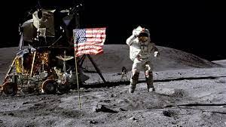  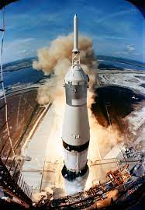 | What I know now…
I know that things were different for the older members of the family.  I know that transport has changed  I know that the moon can be seen in the sky. |  |  | I know who Neil Armstrong is and what he said when he stepped on the Moon for the first time.  I know when people started going into space and then landed on the moon.  I know the main events of the moon landings.
New vocabulary |  |  | What I can do at home
lunar | relating to the moon |  | Find a family member who remembers the Moon Landings, what do they remember?  Did they watch it on the television?
exploration | travelling to a place to discover what is there
achievement | something done successfully after lots of effort

