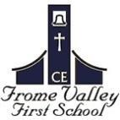

Dear Parents,

Last October, we gave to parent’s information on ‘The Bridge Educational Trust’ who may be able to help towards the costs of the Year 4 trip to Hooke Court.
The Bridge Educational Trust provides grants each year for educational visits to residents of Dorset and have helped parents from other schools locally in previous years. The application process is a simple online form via their website https://www.bridgeeducationaltrust.org.uk/

The trust have their next meeting later in February to consider any applications. However to secure a grant parents need to apply by the 15th February at the latest.

If we can help in anyway with any applications, please speak to the school office as soon as possible.

