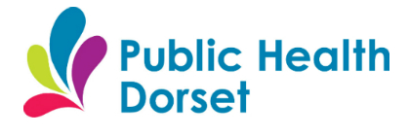
Public Health Dorset
First Floor, Princes House
Princes Street
Dorchester
Dorset
DT1 1TP

Children and Young People’s Public Health Service
East Dorset team: 01425 891150
West Dorset team: 01305 752395
Public Health Dorset: 01305 224400

Dear Parent/ Carer

Height and weight checks for children in Reception and Year 6

Each year in England, school children in Reception and Year 6 have their height and weight checked at school as part of the National Child Measurement Programme. Height and weight measurements are used to calculate weight status. We collect this information because it is in the public interest to understand how many children are over-weight, healthy- weight or under-weight. Your child’s class will take part in this year’s programme.

The checks are carried out by trained school nurses or trained health care providers. Children are measured fully clothed, except for their coats and shoes, in a private space away from other pupils.

It is important to recognise that each child is different, and their weight can change over time and as they grow. It is also important to recognise that being under-weight or very over-weight can lead to health problems, both as a child and in the future as an adult.

How and why the information is collected and what it is used for

- your child’s age, gender, and date of birth are used to calculate your child’s weight category
- your child’s name, date of birth and NHS Number are used to link your child’s measurements from Reception and Year 6. Other data sets may also be linked such as your child’s dental survey results or any visits to hospital they may have had. Linking your child’s information in this way helps us to understand how and why the weight status of children is changing, and how this affects children’s health as a population
- your child’s ethnicity and address are used to help understand some of the reasons for the difference and changes in child weight across England
- once measurements are completed, you may receive feedback on your child’s measurements together with information on support and advice that you may wish to use
- receiving a feedback letter will be followed by a telephone call from a member of the Children’s Public Health service (school nursing) for an opportunity to ask questions about the feedback letter or seek any further support you may wish to have

All information is treated confidentially. Measurements will not be shared with your child, your child’s school or with other children. All of the data collected is also used for improving health, care and services through research and planning.

How the data is used

The information collected from all schools in the area will be gathered together and held securely by our Children’s Public Health service (school nursing) service providers, Dorset HealthCare University NHS Foundation Trust (DHC). They will store your child’s information as part of their local child health record on the NHS’s child health information database.

All the information collected about your child will be sent by us to NHS Digital. NHS Digital is responsible for collecting data and information about health and care so that this can be used to monitor and improve the care provided to people across England.

The information collected about your child will also be shared by NHS Digital with Public Health England but in a de-personalised form only. This means Public Health England will not be able to identify your child. Public Health England is responsible for working to protect and improve the nation’s health.

Both NHS Digital and Public Health England will use the information from the National Child Measurement Programme to better understand numbers and trends in child weight and body mass index (BMI). This helps with the planning of services to support healthy lifestyles in your area. No information will ever be published by NHS Digital or Public Health England that identifies your child.

De-personalised information from the National Child Measurement Programme may also be shared by NHS Digital with other organisations, such as universities. This is to help improve health, care and services through research and planning. This information cannot be used to identify your child, and NHS Digital only ever shares information for research with the approval of an independent group of experts.

Withdrawing your child from the National Child Measurement Programme

If you are happy for your child to be measured, you do not need to do anything.

If you do not want your child’s height and weight to be checked, or your child has a medical condition that affects their height or weight please inform your child’s school as soon as possible after reading this letter.

Children will not be made to take part on the day if they do not want to.

Further information

Click on the following links for further information:

- National Child Measurement Programme
https://www.nhs.uk/live-well/healthy-weight/national-child-measurement-programme

- Fun ideas to help children stay healthy
https://www.nhs.uk/change4life

- GDPR (General Data Protection Regulation) and local data collection, and privacy policies
https://ico.org.uk/for-organisations/guide-to-the-general-data-protection-regulation-gdpr

https://www.dorsethealthcare.nhs.uk/about-us/your-information/privacy-notice

http://www.publichealthdorset.org.uk/privacy/

- NHS Digital and Public Health England information collection
https://digital.nhs.uk/about-nhs-digital/our-work/keeping-patient-data-safe/how-we-look-after-your-health-and-care-information

https://www.gov.uk/government/organisations/public-health-england/about/personal-information-charter

- Organisations NHS Digital has shared information from the National Child Measurement Programme
https://digital.nhs.uk/services/national-child-measurement-programme

- Children’s Public Health service (school nursing) providers, Dorset HealthCare University NHS Foundation Trust (DHC) and how to access services for children and young people through the service can be found at
https://www.dorsethealthcare.nhs.uk/patients-and-visitors/our-services-hospitals/physical-health/school-nursing

- Support and advice for adult healthy lifestyle and behaviour change can be found at LiveWell Dorset
https://www.livewelldorset.co.uk/

- BMI calculating tool can be found on when typing National Child Measurement Programme in the search box and scrolling down the page
https://www.nhs.uk

Where to find support after the measurements

It is important to us that after the measurement, you have opportunity to discuss your child’s result and find the right support for you and your child.

- If your child is identified as being underweight or very over-weight you will receive a feedback letter followed by a telephone call to offer you advice and support.

The letter will be addressed to you as a parent or carer and it is for you to decide if it is appropriate to share this result with your child.

- If you do not receive a feedback letter but have any questions you wish to ask regarding your child’s health, including lifestyle, please do contact your Children’s Public Health service (school nursing) service for support on the number at the top of this letter.

You are welcome to contact the Children’s Public Health service (school nursing) service or your family GP for support at any point if you are concerned about your child’s weight, you do not have to wait for the measurements to be completed or to receive feedback from a measurement result.

- The Children’s Public Health service (school nursing) service will also be working with schools in promoting healthy lifestyles, which may include additional activities for children and families. Look out at your school for any activities or signposting during term and holiday time.

- Find lots of healthy eating ideas, activity and lifestyle tips and resources at Change4Life
https://www.nhs.uk/change4life/activities

Yours faithfully

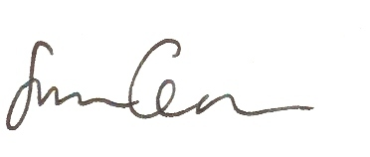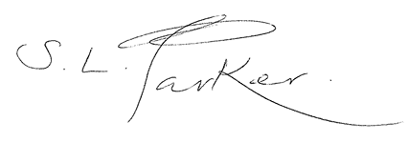
Sam Crowe

Director of Public Health for
Dorset Council and
Bournemouth, Christchurch & Poole Council
Sarah Parker

Executive Director of People – Children
Dorset Council

